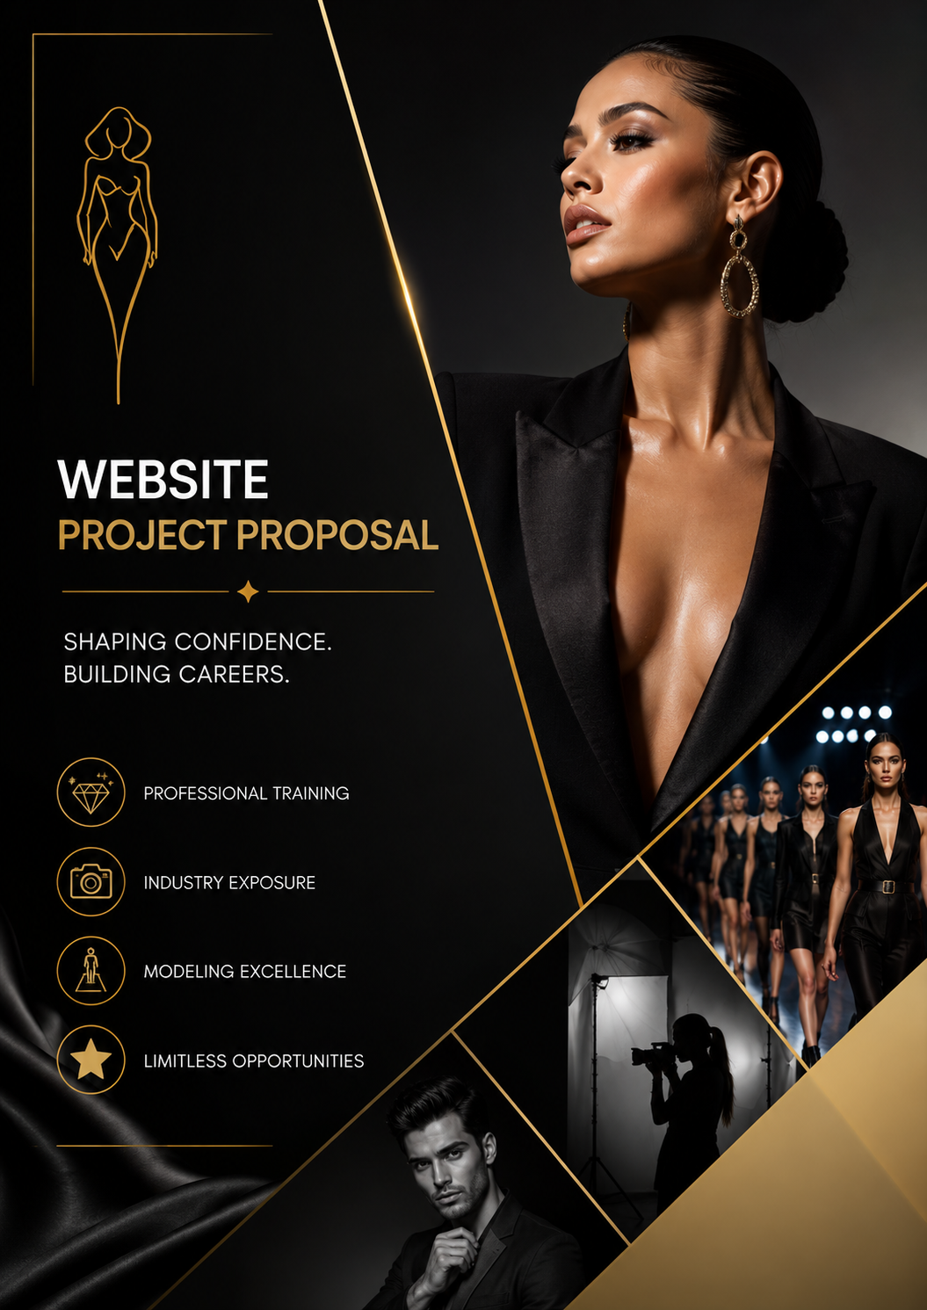 | 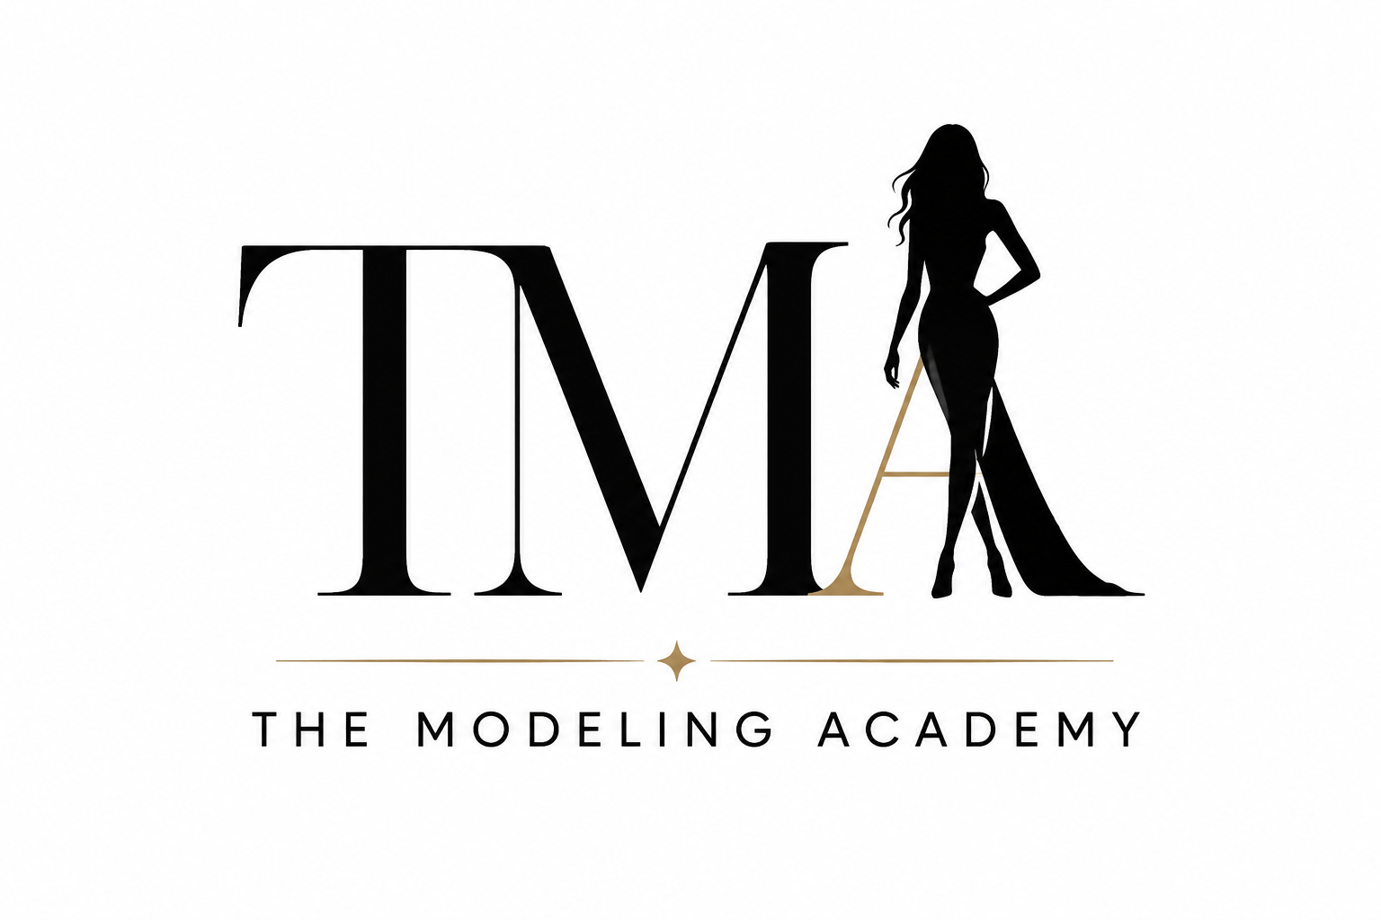  Name: Owam Student Number:ST10517860 Module: WEDE5020 Date: 1 August 2026  Owam Mtebeni

Table of Contents
Contents
Table of Contents 1
Proposal 1: The Modeling Academy 2
1. Organization Overview 2
2. Website Goals and Objectives 3
3. Current Website Analysis 3
4. Proposed Website Features 3
5. Design and User Experience 5
6. Technical Requirements 5
7. Timeline 6
8. Estimated Budget 6
9. References 7

Proposal 1: The Modeling Academy

Organization Overview
Organization Name: The Modeling Academy
History:
The Modeling Academy is a fictional modelling agency and training institution established in 2022. It was created to help aspiring models develop professional skills while connecting them with fashion brands, photographers, designers, advertising companies, and talent scouts. The academy offers training programs for runway modelling, commercial modelling, fashion photography, etiquette, personal branding, fitness, and confidence building.
Mission:
To develop confident, professional, and industry-ready models by providing world-class training and career opportunities.
Vision:
To become Africa's leading modelling academy that discovers and develops diverse talent for both local and international fashion industries.
Target Audience
- Aspiring models (16-35 years)
- Fashion enthusiasts
- Clothing brands
- Designers
- Photographers
- Talent scouts
- Event organizers

Website Goals and Objectives
The website will:
- Recruit new students.
- Allow online course registrations.
- Showcase successful graduates.
- Promote upcoming casting calls.
- Display modelling courses.
- Accept enquiries from agencies and brands.
- Increase online visibility.
KPIs
- 1 500 monthly visitors
- 300 online enquiries per month
- 100 online registrations every quarter
- 20% increase in social media followers
- Reduced response time through enquiry forms

Current Website Analysis
Since this is a new fictional organization, no website currently exists.
Areas requiring development include:
- Professional online branding
- Easy navigation
- Mobile responsiveness
- Search Engine Optimization (SEO)
- Online registration system

Proposed Website Features
The website will include:
- Home Page
Introduces The Modeling Academy, displays the main purpose of the organisation, highlights important information and provides navigation to the other pages. It also includes call-to-action buttons such as registering as a model or viewing courses.
- About Us
Provides information about The Modeling Academy, including its history, mission, vision, values and purpose. It helps visitors understand what the organisation does.
- Programs
Displays the different modelling courses and training programs offered by the academy. It provides information about what students can learn, such as runway walking, posing, photography and personal presentation.
- Gallery
Displays images of modelling activities, training sessions, events, photoshoots and other academy activities. Its purpose is to give visitors a visual understanding of the academy.
- Success Stories
Showcases achievements and experiences of students who have participated in the academy. This page helps demonstrate the potential benefits of the academy's training.
- Upcoming Events
Provides information about upcoming modelling workshops, training sessions, masterclasses and fashion showcases. Visitors can use this page to find out about future academy activities.
- Model Registration Form
Allows aspiring models to submit their personal information and register their interest in joining The Modeling Academy or participating in its courses.
- Contact Page
Provides visitors with contact information such as email, telephone number, operating hours and academy locations. It also includes a contact/enquiry form.
- Frequently Asked Questions
Provides answers to common questions about the academy, programs, registration, modelling experience, events and other important information.
Functions:
- Online registration
- Contact form
- Newsletter subscription
- Embedded Google Maps
- Social media links
- Image gallery
- Responsive design

Design and User Experience
Color Palette
- Black
- White
- Gold
- Light Grey
These colours represent elegance, professionalism and luxury.
Typography
Poppins and Montserrat will be used for the website typography (Google Fonts, 2026).
Layout
Modern full-width layout with large photographs, simple navigation, clear call-to-action buttons and spacious sections.
Planning:
Figma will be used to create the sitemap and low-fidelity wireframes (Figma, 2026).
Industry research:
Models.com was consulted when researching the modelling industry (Models.com, 2025).

User Experience
- Simple navigation
- Mobile-friendly
- Fast loading pages
- Accessible contact information
- Easy online registration
Low-Fidelity Wireframes
The low-fidelity wireframes were created using Figma to plan the layout and structure of the website before development (Figma, 2026).

Sitemap
The sitemap was created using Figma to show the structure and navigation between the website pages (Figma, 2026).

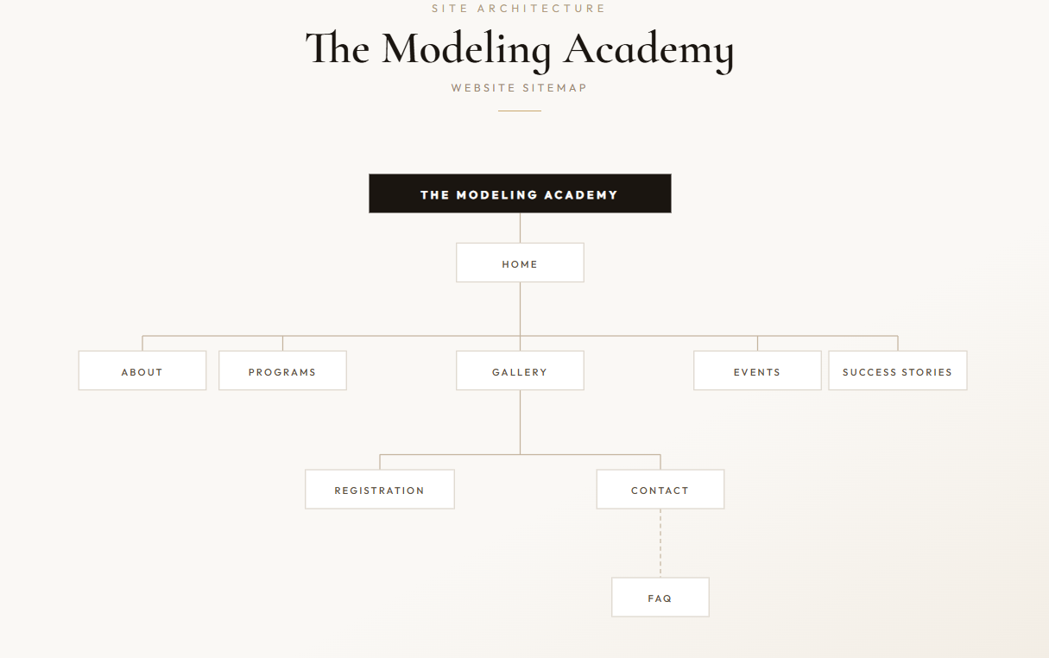

Technical Requirements
- HTML5 and CSS3 will be used to create and style the website (MDN Web Docs, 2026; W3Schools, 2026).
- JavaScript
- VS Code
- GitHub
- Google Maps Embed
- Responsive Web Design

Timeline
Week 1
Research and planning
Week 2-3
Wireframes and content collection
Week 3-4
HTML development
Week 4-7
CSS
Week 7-9
Java script

Estimated Budget
Item | Cost
Domain | R250/year
Hosting | R1 200/year
Design & Development | R15 000
Maintenance | R500/month
Images & Marketing | R3 000
Total | R25 450

References
- MDN Web Docs. 2026. HTML: HyperText Markup Language. Available at: https://developer.mozilla.org/en-US/docs/Web/HTML (Accessed: 1 August 2026).
- W3Schools. 2026. HTML Tutorial. Available at: https://www.w3schools.com/html/ (Accessed: 1 August 2026).
- W3Schools. 2026. CSS Tutorial. Available at: https://www.w3schools.com/css/ (Accessed: 1 August 2026).
- Google Fonts. 2026. Google Fonts. Available at: https://fonts.google.com/ (Accessed: 1 August 2026).
- Font Awesome. 2026. Font Awesome. Available at: https://fontawesome.com/ (Accessed: 1 August 2026).
- Figma. 2026. Figma Design and Prototyping. Available at: https://www.figma.com/ (Accessed: 1 August 2026).
- OpenAI. 2026. ChatGPT. AI-generated images created using ChatGPT for The Modeling Academy website. (Accessed: 1 August 2026).

AI-Generated Images
The modelling images used on the website were generated using ChatGPT (OpenAI, 2026) and were used for educational and design purposes as part of the WEDE5020 project.

GitHub Repository link
https://github.com/OwamMtebeni/The-Modeling-Academy

